How to talk to your child about gender equality
Source: www.paretns.actionforchildren.org.uk

Gender equality can sometimes feel like a complicated issue. Your child may have questions about some of the things they’ve seen on social media. But as a parent, even little things can make a difference and help your child understand.
Understand what gender equality is:
Gender equality is when access to rights or opportunities is unaffected by gender. People can experience gender inequality in a number of ways. This includes:
- Jokes, stereotypes, unacceptable use of language and objectification.
- Harassment, threats and verbal abuse.
- Emotional and financial abuse.
- Rape, sexual assault and physical abuse or violence.
UN Women explains that gender is not about biological differences between sexes: “People define what it means to be a boy or a girl. These social conditionings often expect children to confirm to specific and limiting gender roles and expectations from a young age.”
Have open conversations:
Look for moments to talk to your child about the topic of equality.
- Think about how you see things – what’s your perspective? Ask what you already know or believe. Why do you believe that? Can you see it from another person’s view?
- Listen to your child and their experiences and opinions. Let them tell you what they feel. Respect them even if you have different views.
- Talk to your child about ways they might be able to support gender equality. Reading books like Be The Difference by Jayneen Saunders can help with this.
- Speak to your child about what they’re seeing on social media and the influences around them. Challenge any damaging stereotypes you come across. This can help your child understand why they’re harmful.
- Share your own experiences and knowledge with your child.
- If you feel your child is old enough, talk to them about consent and respect. Help them to understand boundaries and what is and isn’t OK. Talk to them about things like flirting and explain when that may become harassment. Be open and honest. Help them to feel confident discussing those things with you.

Promote gender equality in the home:
Think about how you can help promote gender equality in your daily actions and habits.
- Let your children play with whatever toys they like regardless of their sex. All play helps children to develop life skills.
- Try to be a role model to your child. Show examples of gender equality in the home. If you have a partner, try to share jobs out equally. Everyone can help with things like cooking, cleaning, gardening, or washing the car.
- Challenge stereotypes. For example, girls and women are often represented by sexist and racial stereotypes. Look at powerful and inspirational people of all genders and ethnic identities from history. Celebrate them for their strengths. Teach your child to be proud of who they are.
- Look at diversity in the world. Explore different cultures with your child using books, films and music.
- Teach your child to understand and respect their body. Be aware of how things like social media might affect how they think they should look. Promote self-care and encourage self-confidence.
- Remember that all human beings have feelings and need to express these feelings. It’s OK to show emotions, whatever your sex or gender identity.

Support your child’s understanding as they grow:
As your child gets older, you can continue to teach them about gender equality. Help them understand how this influences the way they treat themselves and others.
- Accept different experiences – give your child space and freedom to be whoever they want to be. Don’t pre-determine their sexual orientation or perceptions of their own gender. Avoid judgment. Be there to guide them if they need you.
- Respect your child’s choices about what they want to do with their lives. Help them explore the options and find out about things.
- Make sure they know what they can do if they feel they’ve been a victim of discrimination.

Home-Stages and development-Social and emotional development-How to talk to your child about gender equality

How to talk to your child about gender equality
Gender equality can sometimes feel like a complicated issue. Your child may have questions about some of the things they’ve seen on social media. But as a parent, even little things can make a difference and help your child understand.
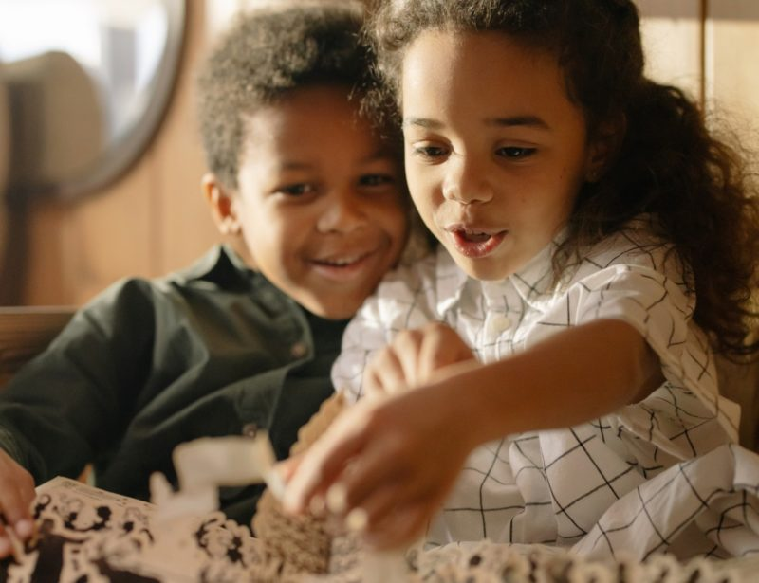

Understand what gender equality means
Gender equality is when access to rights or opportunities is unaffected by gender. People can experience gender inequality in a number of ways. This includes:
- Jokes, stereotypes, unacceptable use of language and objectification.
- Harassment, threats and verbal abuse.
- Emotional and financial abuse.
- Rape, sexual assault and physical abuse or violence.
UN Women explains that gender is not about biological differences between sexes: “People define what it means to be a boy or a girl. These social conditionings often expect children to conform to specific and limiting gender roles and expectations from a young age.”

Have open conversations
Look for moments to talk to your child about the topic of equality.
- Think about how you see things – what’s your perspective? Ask what you already know or believe. Why do you believe that? Can you see it from another person’s view?
- Listen to your child and their experiences and opinions. Let them tell you what they feel. Respect them even if you have different views.
- Talk to your child about ways they might be able to support gender equality. Reading books like Be The Difference by Jayneen Saunders can help with this.
- Speak to your child about what they’re seeing on social media and the influences around them. Challenge any damaging stereotypes you come across. This can help your child understand why they’re harmful.
- Share your own experiences and knowledge with your child.
- If you feel your child is old enough, talk to them about consent and respect. Help them to understand boundaries and what is and isn’t OK. Talk to them about things like flirting and explain when that may become harassment. Be open and honest. Help them to feel confident discussing those things with you.

